Course Setter’s Commentary
By Nick Corsano
These remarks reflect mostly my thoughts in designing the course, but also include some of the insights gained from conversations following the event. As is customary, I will refer to the flags A-E using the phonetic alphabet terms Alpha, Bravo, Charlie, Delta, and Echo. The photos were all taken on earlier trips to Boggs, so some of the flag placement may vary from what was in place during the event.
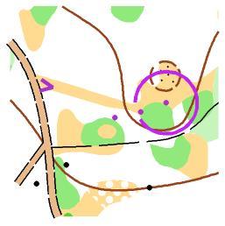 | Timed Control #1  Feature: Northern side of western thicket  There are lots of beautiful boulders on Boggs Mountain, but sadly, few map-worthy rock features are found in the vicinity of our road. I was eager to do something with the little rocky knoll, but it didn’t work as a control location itself, due to the lack of similar features. It did serve, however, as a useful reference point in relation to the group of thickets to the south. I placed the center of the control circle on the nearest boundary point. The proximity of Alpha to the knoll is discernible from the viewing station. A secondary clue is that the strip of open land points almost directly at Bravo, but that point is somewhat west of the center of the circle.  Solution: Alpha | 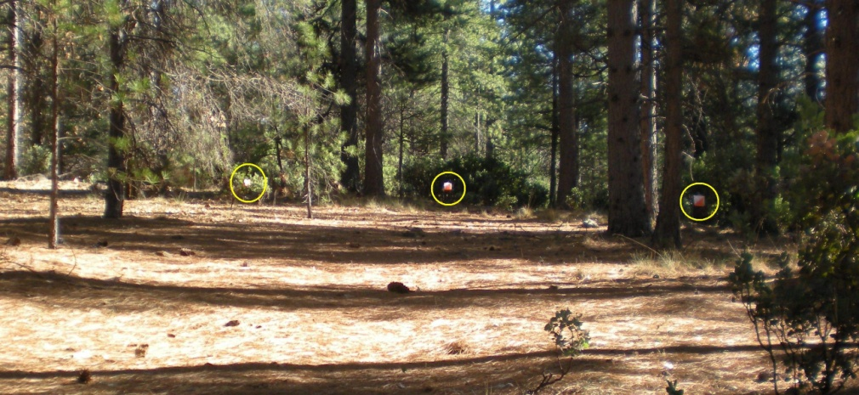
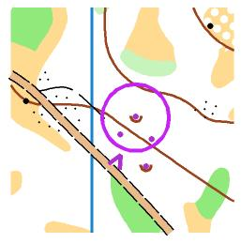 | Timed Control #2  Feature: Depression  I hope the control description didn’t match anybody’s mood so early in the course! There are two mapped depressions in the area. There are three depressions visible (Charlie is a red herring). The relative depths of the depressions can be estimated by observing how high the controls are above the surrounding ground (in Trail-O, it’s an important principle that all the flags at a control must be at the same height above the ground). Bravo and Delta are clearly deeper than Alpha, and therefore more deserving of being mapped. Their positions relative to the road and to each other are also compatible with the map. A further clue (harder to use for a timed control) is that the viewing station is opposite the tip of the medium green on the other side of the road.  Solution: Bravo | 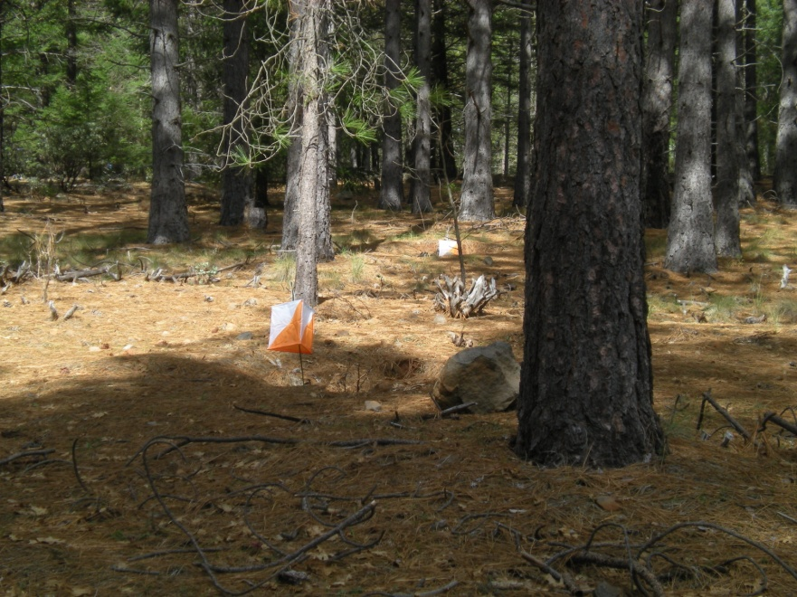  Alpha and Bravo  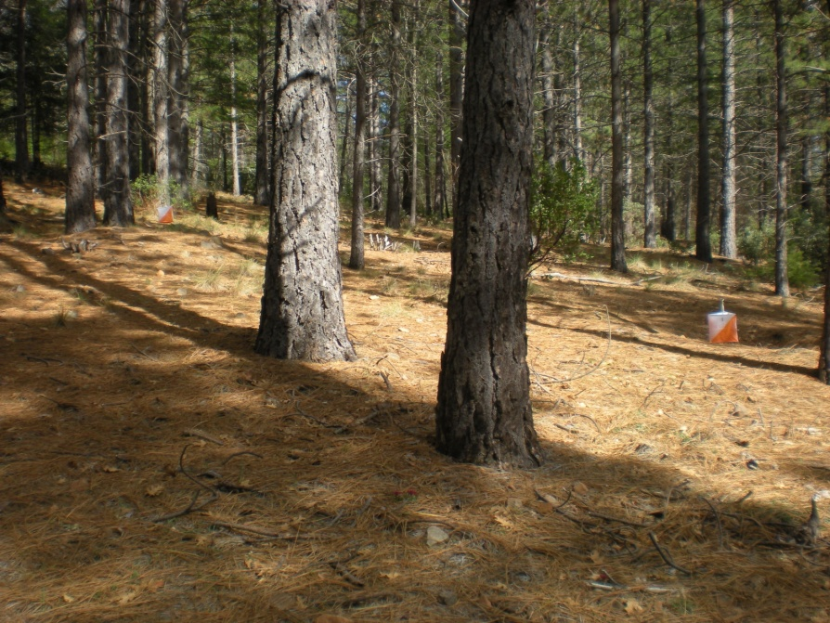  Charlie and Delta
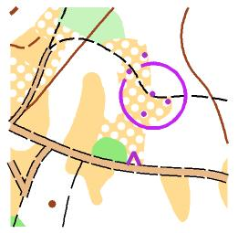 | Control #1  Feature: Bend in trail  I like to refer to this as my “Goldilocks” control: Alpha is too far to the left; Echo is too far to the right; Bravo is too far away; Charlie is too close; but Delta is just right! To be more analytic about it, the key to this control lies in the vegetation. The control has scattered trees in front, and true forest behind. The distinction in this area is clear enough, and only Bravo and Delta meet this condition. Bravo is over 50% farther from the road than Delta, so distance estimation should resolve that.  Solution: Delta  A side note: I did my first Trail-O at Northstar in 2000 (course designed by David and Karen). The first control was “Bend in trail”, where you couldn’t see the trail. By the time I had solved that (correctly!), I was pretty much hooked on Trail-O. | 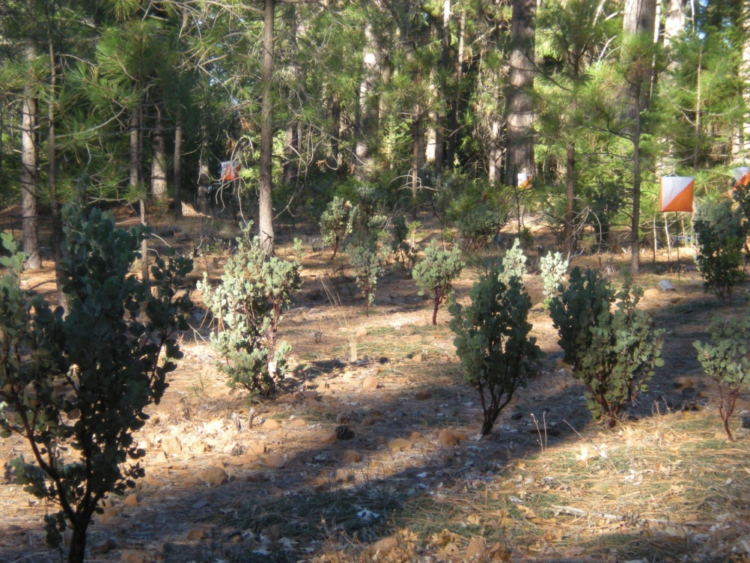  Note: Echo is out of the picture to the right.
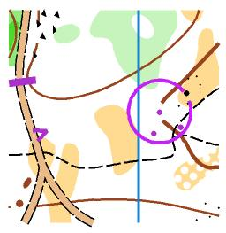 | Control #2  Feature: Re-entrant  Competitors get a really nice view of this control walking up the road. You can see that one flag is below the trail junction, and if you follow along as you go, you identify that as Bravo. The way the re-entrant bends as it comes uphill, you can deduce that the correct flag has to be to the left. Note: I used 5’ stakes at this control so the lowest flag would be visible over the sloping terrain.  Solution: Alpha | 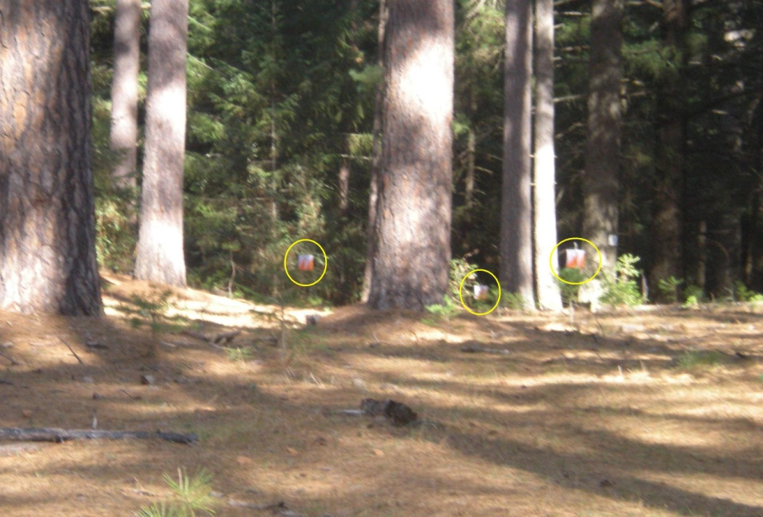
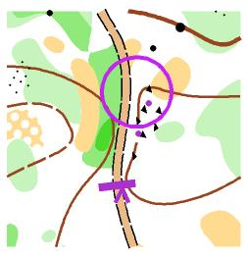 | Control #3  Feature: Northwest side of boulder cluster  In Trail-O, it is unacceptable for Zero to be the correct answer just because flag placement is “not quite right”. There has to be convincing evidence that none of the flags matches both the control circle and the clue. If the clue were simply “boulder cluster”, this would be a “not quite right” control. But the “side” modifier fixes that. Side implies outside the borders of the rocks. Bravo is outside, but is at the crest of the little rise, so not our choice. Alpha is quite close to the center of the circle, but is located in the interior of the boulder cluster, so it can’t be the right answer.  Solution: Z | 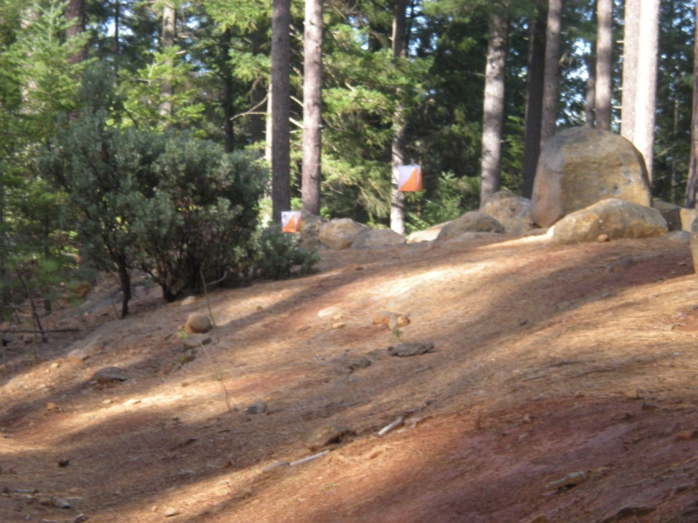
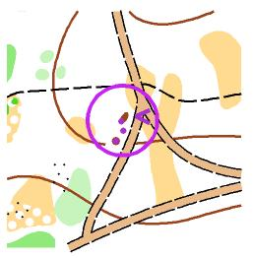 | Control #4  Feature: Southwest part of northwest knoll  How hard can a control be when you can reach out and touch the flags? In this case, not very. The little mound in the middle is too small to be mapped, so that leaves the two end controls. Your compass does the rest of the work.  Solution: Charlie | 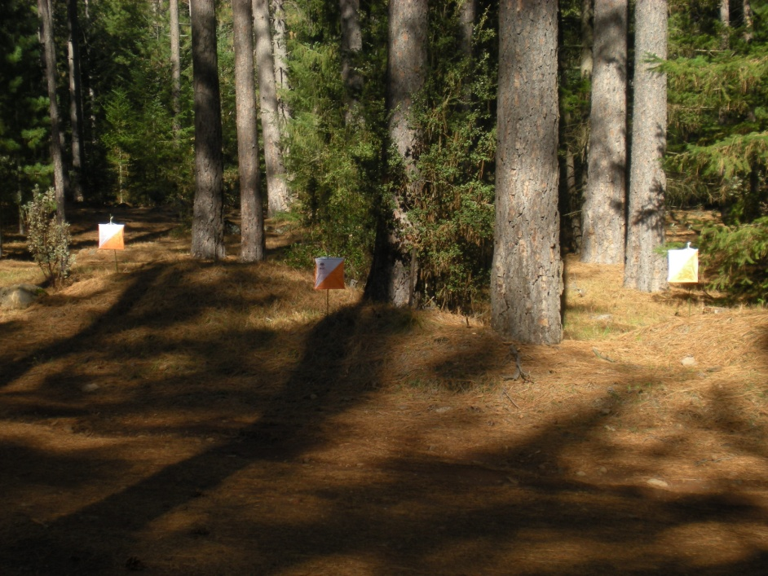
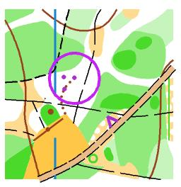 | Control #5  Feature: Northwest end of erosion gully  This control generated by far the most post-race discussion. There is an abundance of points of reference and lines of sight here with the two intersecting rides, the clearing and its boundaries, the different flavors of vegetation, even the single tree across the road providing different outlooks on the problem. Even slight map distortions in such a confined space (all flags are within 40 m of the road) can give conflicting indications to an orienteer. My approach to the control was that sighting across the cleared area southwest of the viewing station shows Alpha at the point of maximum curvature of the gully, and Bravo behind the presumed continuation of the curve. Charlie is not visible from here, but other viewpoints show it positioned consistent with the map relative to the two rides.  Solution: Charlie | 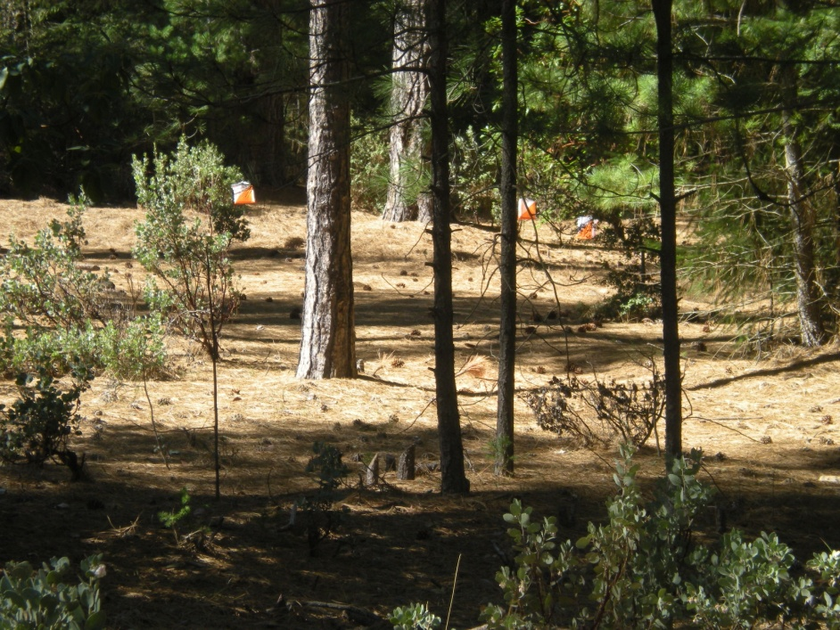
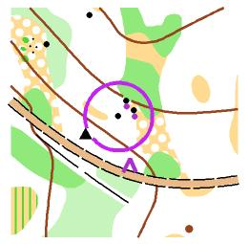 | Control #6  Feature: Southwest boulder, south side  There are times when the Trail-O course-setter is simply trying to trick the orienteers. This is one. The vegetation obscures much of the scene. If competitors move a little bit back and forth to get a better view of the flags, they can sometimes lose sight of the bigger picture, in this case, the lower boulder, out of sight from the viewing station, where the control circle is placed.  Solution: Zero | 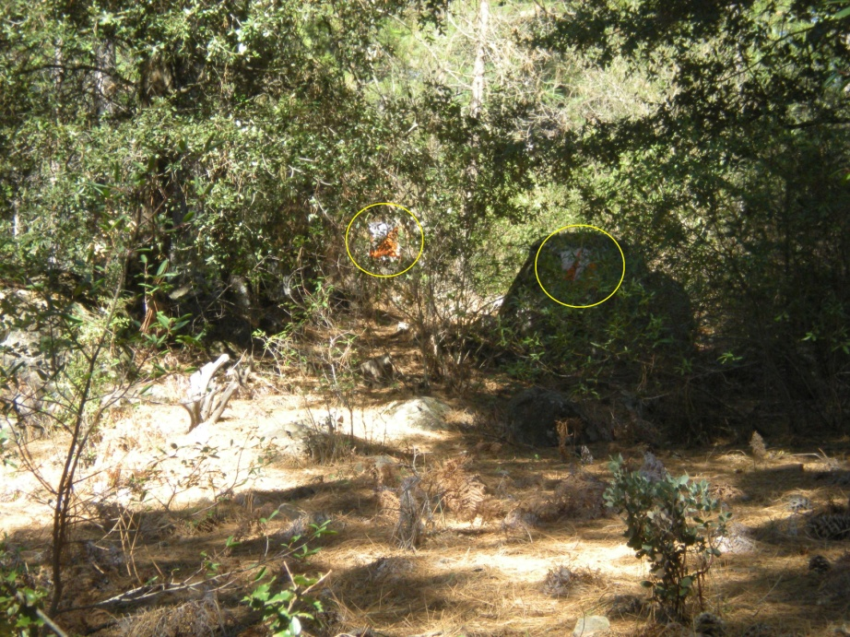
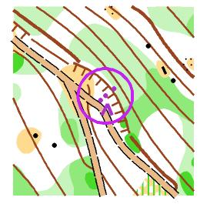 | Control #7  Feature: Earth bank  It is fairly well known among orienteers that if a feature on a clue sheet has no positional modifier, one is to assume “middle of”. A cliff/rock face/earth bank is a linear feature, so “middle of” refers to left-to-right position. All three of the flags lie on this center line. The more arcane principle is that for such vertical features, an unmodified clue implies “bottom of”. At this point, we can eliminate Charlie, the flag at the top of the earth bank. Now if you look at how the earth bank is drawn on the map, you will observe that the tines of the symbol do not extend down to the road, and the control circle is centered at the lower end of those tines. The conclusion is that the mapper considered only the upper portion of the slope as comprising the earth bank, so Bravo is the correct choice.  Solution: Bravo | 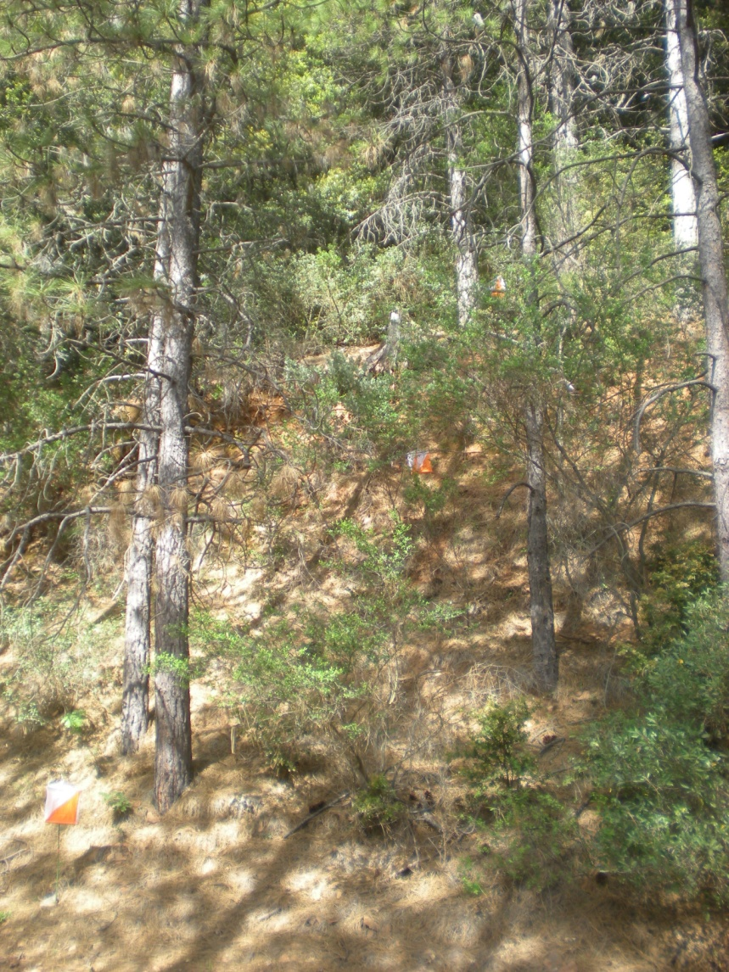
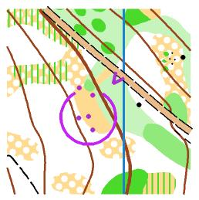 | Control #8  Feature: Western part of clearing  I struggled with this clearing for hours over several visits to the park, to try and get it to yield a satisfying control. In the end, I almost succeeded. Both as a competitor and a course designer, I tend to think of compass bearings last as a solution strategy. Here, bearings were the key. I had hoped that there might be three bearings which in combination would pinpoint the correct flag. The first, from above the little boulder, would suggest either Bravo or Delta as the solution. I think most people looked at this. The second was from a spot about 60 meters downhill where there was a good lengthwise view of the clearing. From here, Alpha, Bravo or Echo would be the possible candidates. The third one was going to be from the top of the little “open” strip, where Bravo and Charlie would align, but I couldn’t make that one match my earlier measurements.  Solution: Bravo | Sorry, I don’t have a good photo of #8.
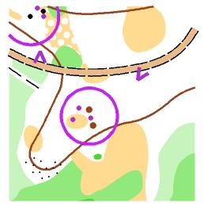 | Control #9  Feature: Between the knolls  In this lumpy patch of ground, the two biggest lumps are the best candidates for the mapped knolls, and this is easily confirmed by sighting from the patch of medium green on the other side of the road.  Solution: Alpha | 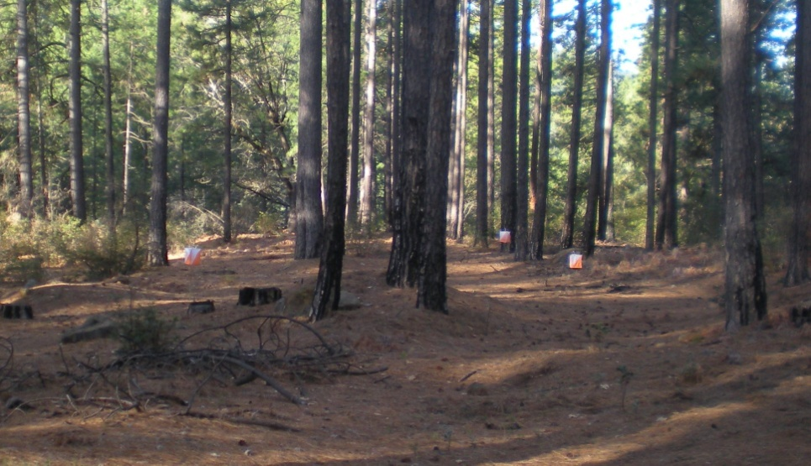
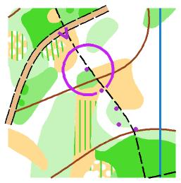 | Control #10  Feature: Northern tip of thicket  It was not my first choice to make the nearest flag the correct answer here, but unfortunately, not enough of the varied vegetation to the west of the trail could be seen well enough from the intersection to justify using one of the intermediate points. Oh well, at least one gets to punch in a seldom-used column.  Solution: Echo | 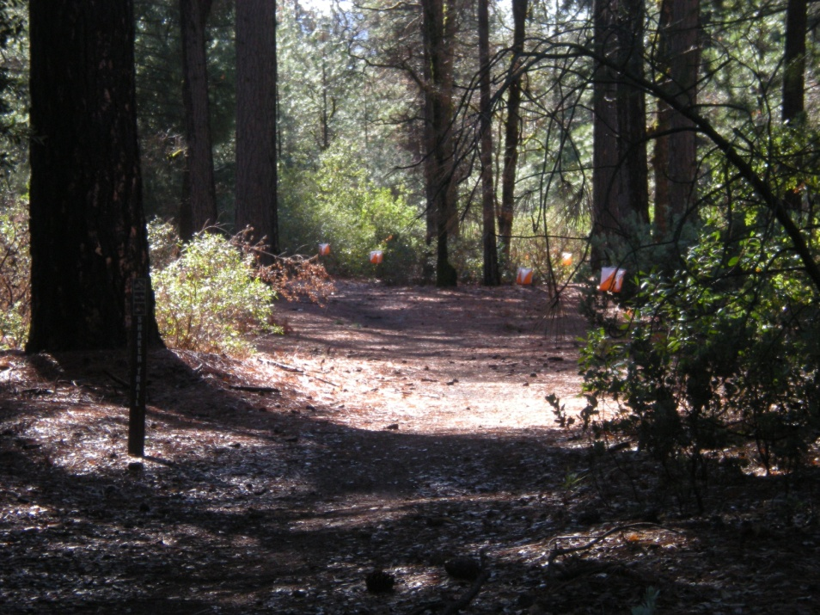
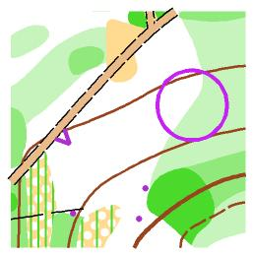 | Control #11  Feature: Vegetation boundary  This is a variation on the parallel error control, where a cluster of flags surround a feature which resembles the control feature, but is some distance away. Here I just used a different section of the vegetation boundary (denser forest), hoping that brain weariness might entrap some orienteers. The extra misleading clue was the open patch on the other side of the road, which might be mistaken for the mapped rough open about 50 meters further up the road.  Solution: Zero | 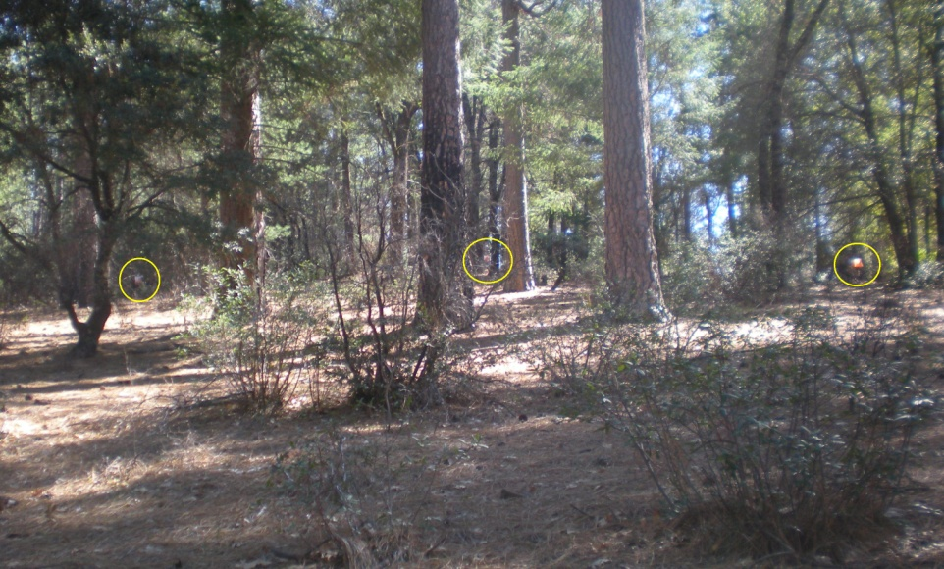
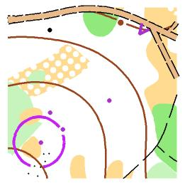 | Control #12  Feature: Northeast edge of clearing  On this sparsely wooded hillside, all four flags border clear areas extending in similar directions, but the presence of rocky ground to the left and thicker vegetation to the right should rule out all except Charlie and Delta. The best clues to distinguish between these is that Charlie can be seen to lie more on the “point” of the spur, and that Delta lines up too closely with the bushes when observed on approach to the viewing station.  Solution: Charlie | 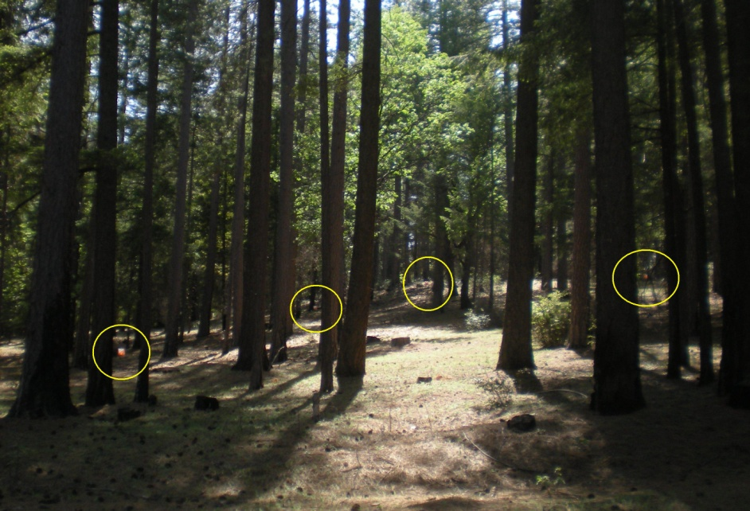
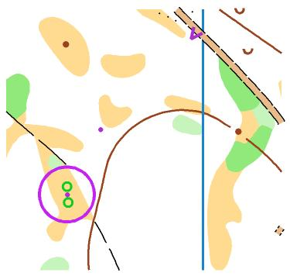 | Control #13  Feature: Between distinctive trees  On an early course planning trip, I asked myself “What happens if I put a flag between these two trees?” It turns out you can (just barely) see the flag from at least one spot on the road. And I convinced myself that, although you couldn’t make out the two mapped trees, there were sufficient clues to make this a solvable problem. The clues: first, the two trees are mapped because they sit in a clearing. The clearing can be detected to the left of, and at the same distance as, flag Alpha by a change in the lighting and a change in the nature of the surface from all pine needles to more dirt. Second, the contour line which sweeps gently before you marks a shallow re-entrant, and you can see that Alpha is on upward sloping ground.  Solution: Alpha | 